PRE-K HOME LEARNING
CHOICE BOARD
May 11-15, 2020
Choose an activity to do each day. Don’t worry about crossing off the activities after you have finished. You can do these activities multiple times! We will add more activities each week. Just have fun with this! Be sure to look for updates every Monday on your teacher’s website.
Reading | Math | Science | Movement | Creativity
Here is a wonderful book about caterpillars as they go through the lifecycle stages click below  https://www.youtube.com/watch?v=75NQK-Sm1YY&feature=emb_rel_pause  - Nutrition: time to talk to your child about what foods are good for you and what happens when you eat too much! It’s also a good time to talk about each child’s favorite foods.  - Look through magazines and cut out photos of food.  Each child could paste a series of foods on index cards, punch a hole through the picture and string a piece of green yard through a series of cards to represent the caterpillar eating through all the food.  Watch an animated version of Eric Carle’s The Very Hungry Caterpillar  https://www.youtube.com/watch?v=75NQK-Sm1YY | 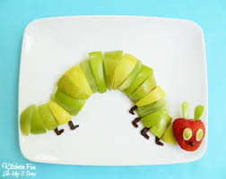  Create a caterpillar snack using apples, strawberries, colored marshmallows, Gushers, your imagination. Count the sections. Continue to count backwards as you eat it.  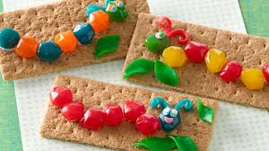  *********************  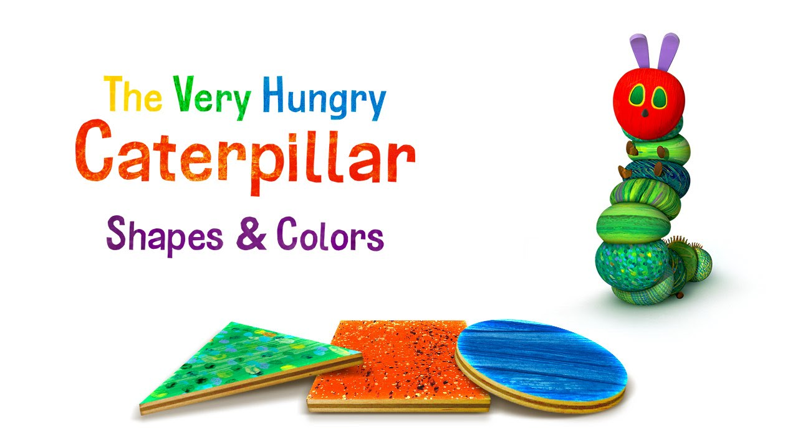  Learn Your Shapes and Colors with these two links:  Shapes song for kids - The Singing Walrus  https://www.youtube.com/watch?v=OEbRDtCAFdU  The Very Hungry Caterpillar™ – Shapes & Colors  https://www.youtube.com/watch?v=0xBQLVF3w60 | National Geographic time lapse video of the butterfly life cycle  https://www.youtube.com/watch?v=kVm5k99PnBk  The Life Cycle of the Butterfly: The story starts out with a little egg on a leaf then follows the caterpillar as it eats and grows, enters a cocoon (most caterpillars enter a chrysalis, but Eric Carle used the word “cocoon” as that’s what his father called it when he was a child) and emerges as a colorful butterfly.  You can simply talk about this process, illustrate it on blank paper or act it out this way –  - Egg: have the children hold onto their ankles, bend down, and round their body into the shape of an egg  - Larva: have the children “squirm like a worm”  - Pupa: have them crawl into a sleeping bag or large pillowcase with colorful handkerchiefs or pieces of cloth inside (they’ll probably have to take turns on this unless you have lots of sleeping bags)  - Butterfly: have them emerge from the “cocoon,” swaying with the handkerchiefs in hand. | Have fun dancing to this song about caterpillars  https://www.youtube.com/watch?v=5gs8_VUSnMQ  ********************  Here is another fun song about the hungry caterpillar  https://www.youtube.com/watch?v=_tUBBh4QzTU&list=PLtcL0epaLCvPxynwF08QMJ9jAuiUyhVMy&index=4  ********************  Listen to this awesome butterfly song!  https://www.youtube.com/watch?time_continue=9&v=Hwych442klo&feature=emb_logo  **********************  Follow along with The Very Hungry Caterpillar A Cosmic Kids Yoga Adventure  https://www.youtube.com/watch?v=xhWDiQRrC1Y | Name Caterpillar  1.Find different colored construction paper or white paper that you can color.  2. Count the letters in your name and cut out that many circles.  3. Write 1 letter of your name on each circle.  4.Place the circles in order to spell your name.  5. Glue the circles in the correct order to make your name.  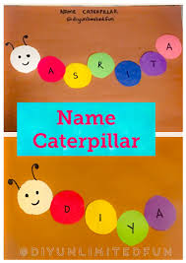  *********************  Use pasta or other materials in your house to recreate the Butterfly Life Cycle  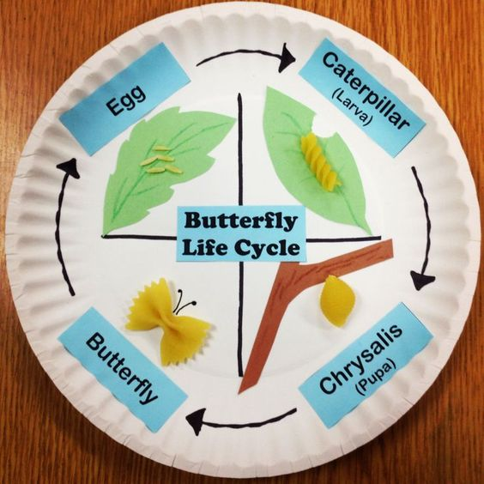
A Butterfly Is Patient Children’s Read Aloud  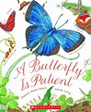  Learn about many beautiful butterflies around the world, as you listen to this story:  https://www.youtube.com/watch?v=VzvuCtNZ2hs  ********************  Watch and sing “Butterfly” and Rhyme along as you sing this song, Mother Goose Club Playhouse:  https://youtu.be/JZpB4zvt-_o | Have fun playing the caterpillar counting game.  https://www.tvokids.com/preschool/games/caterpillar-count | Watch a science show about how a caterpillar becomes a butterfly.  https://www.youtube.com/watch?v=V5RSpMQQOpw  ********************  Make a Butterfly Feeder and do some Butterfly Watching!  Cut up some juicy fruit like oranges, bananas, and strawberries, or any other juicy fruit, lay the fruit in a plastic/aluminum bowl or plate, place outside where you can watch to see what Butterflies come for a drink!  Draw/record what you SEE!  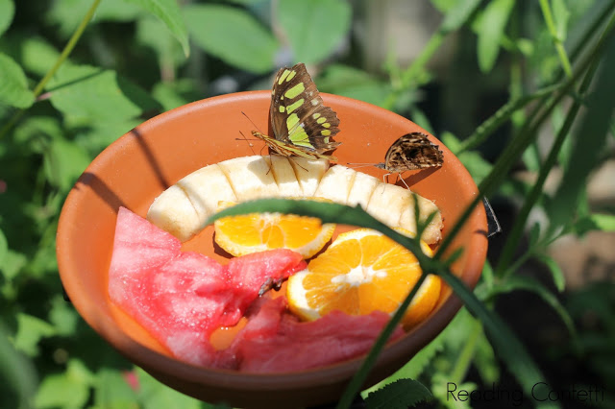  http://www.readingconfetti.com/2013/07/easy-butterfly-feeder.html | Dance and sing to My Little Butterfly.  https://www.youtube.com/watch?v=5YPMKtYTkU8&feature=share | This is a fun way to get creative. Color a butterfly on your computer.  https://www.happyclicks.net/colouring-games/colouring_game_butterfly.php  **********************  Strengthen fine motor skills while making this cute very hungry caterpillar necklace. Use any materials you have at home, such as colored cardboard, beads, buttons, cereal, noodles, etc. A piece of yarn, string, or a couple of pipe cleaners are great to use for stringing necklaces.  